

Songs for the Season

10th December 2016 @ 19:30 - 21:30
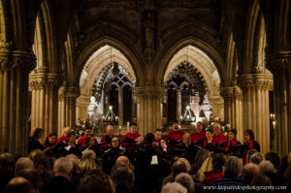
Rudsambee, a group of twenty singers based in Edinburgh. Unaccompanied voices in
harmony, singing a wide range of modern music, world music, renaissance music. The name
comes from the Gaelic expression rud sam bith idir, meaning“anything at all”. Join us for a
beautiful evening of festive music with a few surprises along the way.

Rosslyn Venus-Kalogianni Incantations – the remedy
The remedy was made by four of us in the audience on the evening of this performance
Jemma Foster
Natasha Tillie
Ian Hamilton
Evi Kalogianni
Method: pure water and alcohol (from vodka) exposed to the evening of music in Rosslyn Chapel with a live audience of men, women and children, singing and playing songs and music for two hours. This is an artwork proving. Only a few have ever been made.
The tincture was made up to a 30c potency by Helios Pharmacy. There were 12 provers using a Hahnemannian proving, 4 provers who produced a visual work and 1 who wrote a poem. The results were gathered on spreadsheets and through images and words.
Evi is no longer with us. She passed to another place last year, from breast cancer but we have named the remedy for her. Several people in the proving experienced breast symptoms. Others had a sense of space and time. Duality was another theme. We will publish full results soon.
The images painted by the artists in the Fringe Show who took the remedy are attached, as is the poem written after the poet took the remedy.

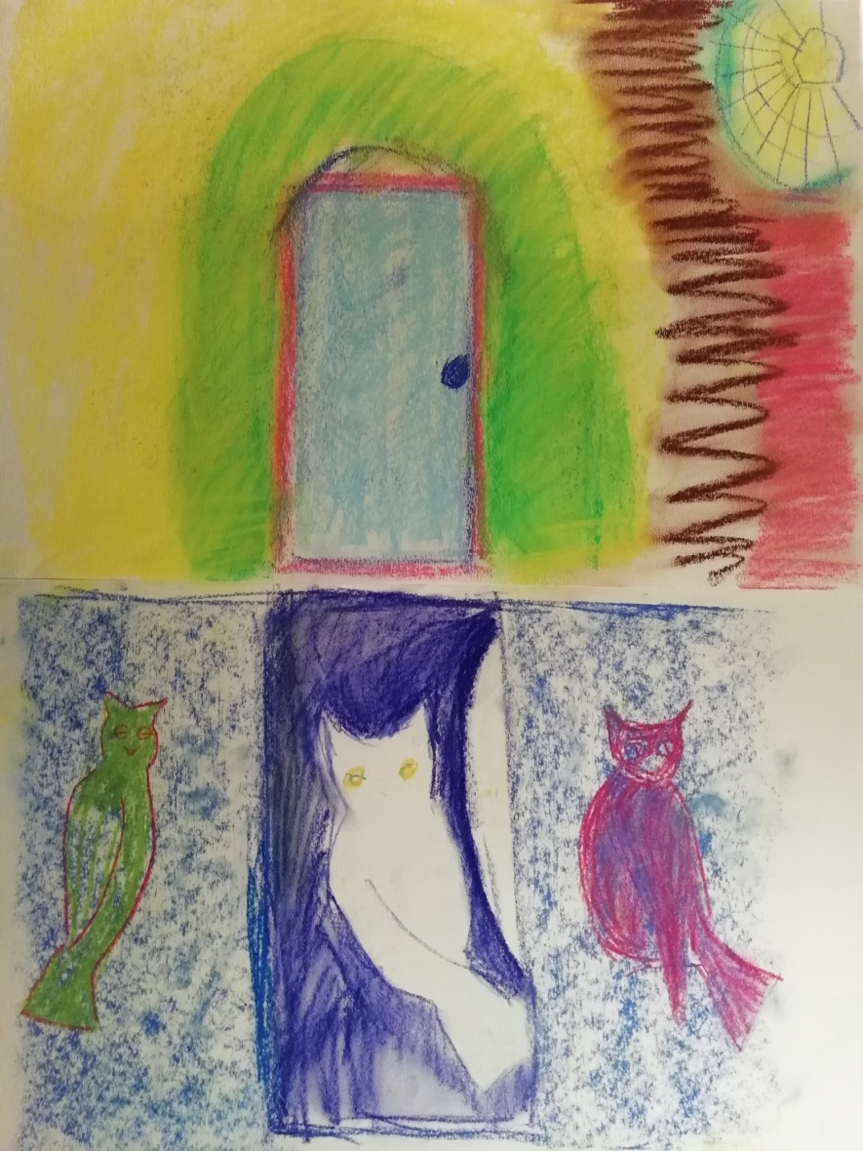

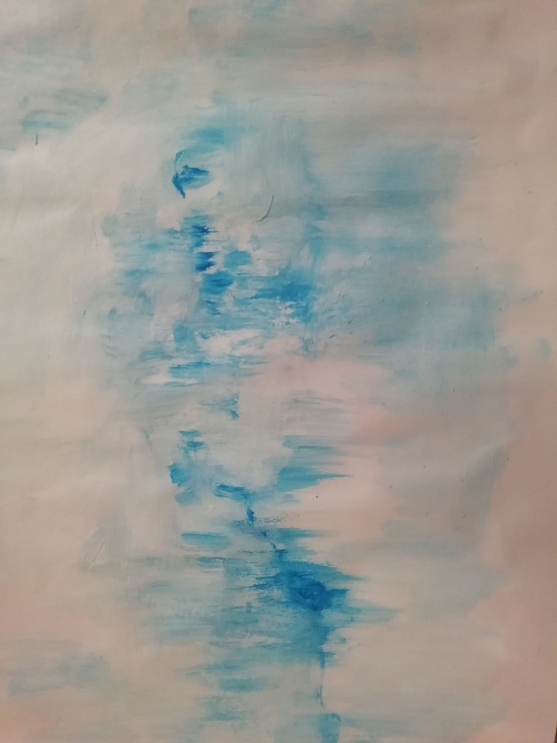

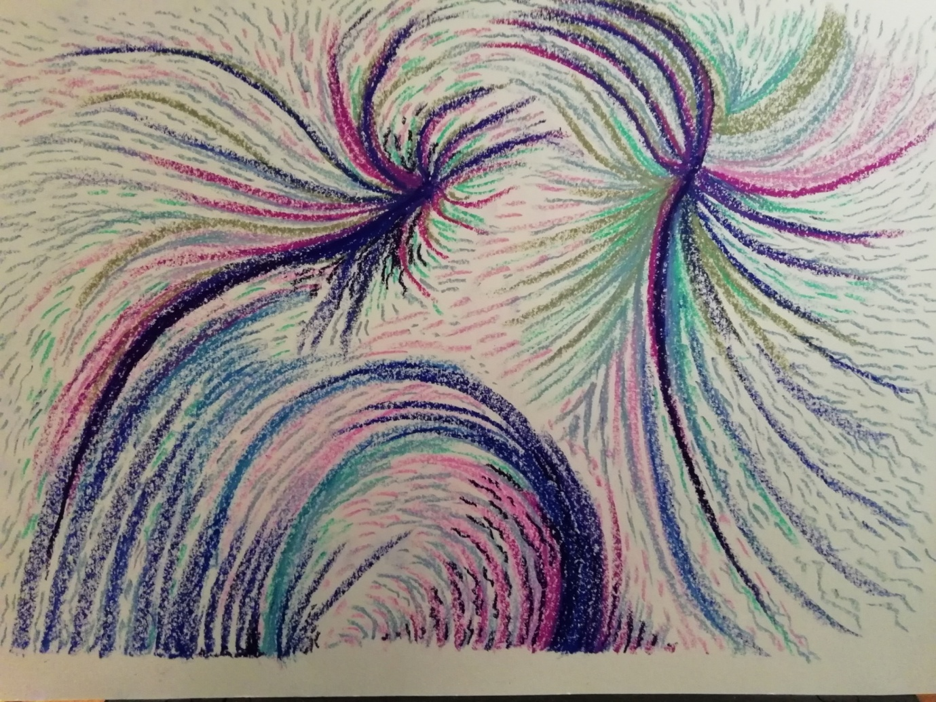

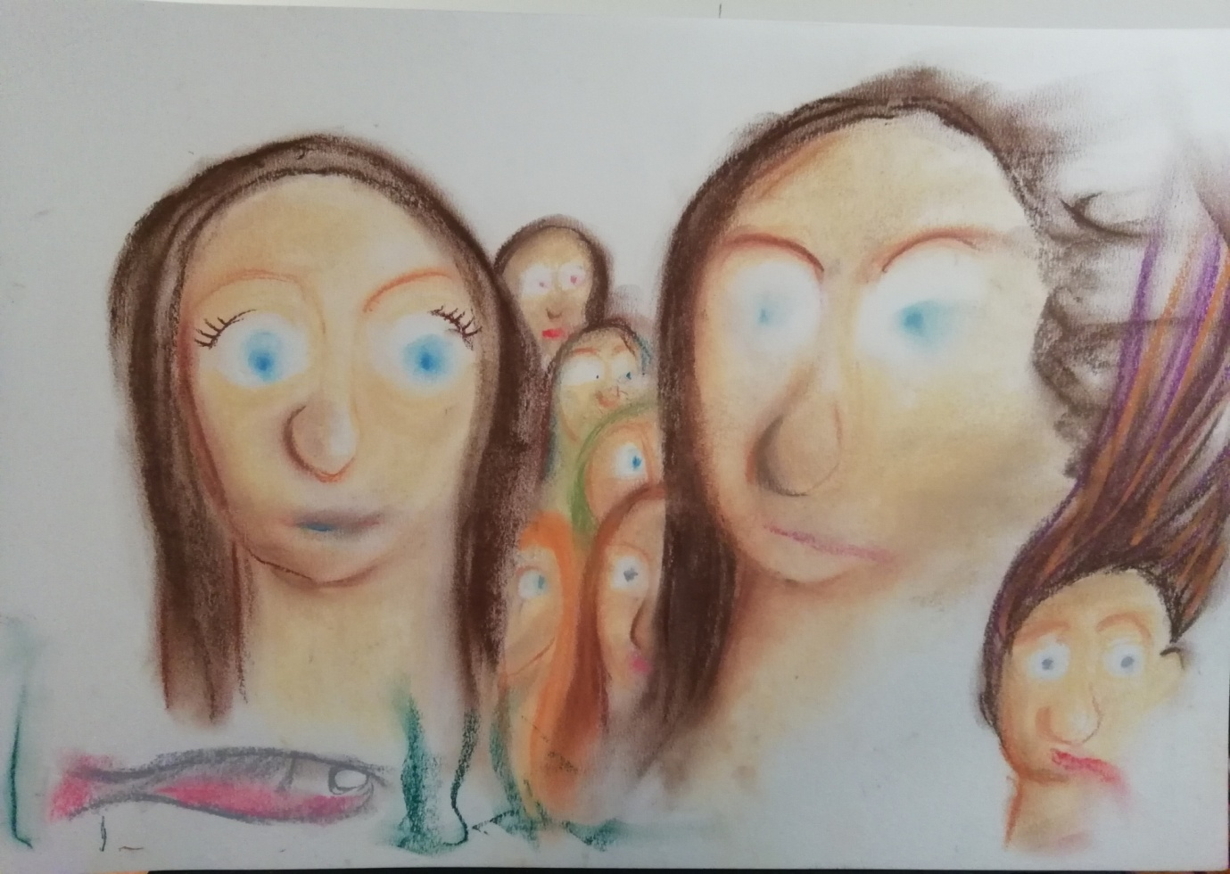
IRMINSUL byFynnStirm
..and now the sun bursts forth
from just one eye; the other one
is absent from its house-
inside its empty socket lies
the world in waste below
the cosmic belt. We sing for joy
to see the cliff-face-clouds
adorn the day despite the barking hounds
who wail their own confounded song
while swirling out of Time. Time’s time
and never will a man who touches ground
escape the living well below his soles-
the words con-fuse; become a standing stone
to know there ever only was one single I;
the absent other is your shadow casting soul
dressed briefly in the flash your mind enfolds….

