CASE OF AH, 44 year old totally grey haired female with special needs
I was painting with this woman for a few years before she had any homeopathy
These are examples of the pictures she did at first before any remedies
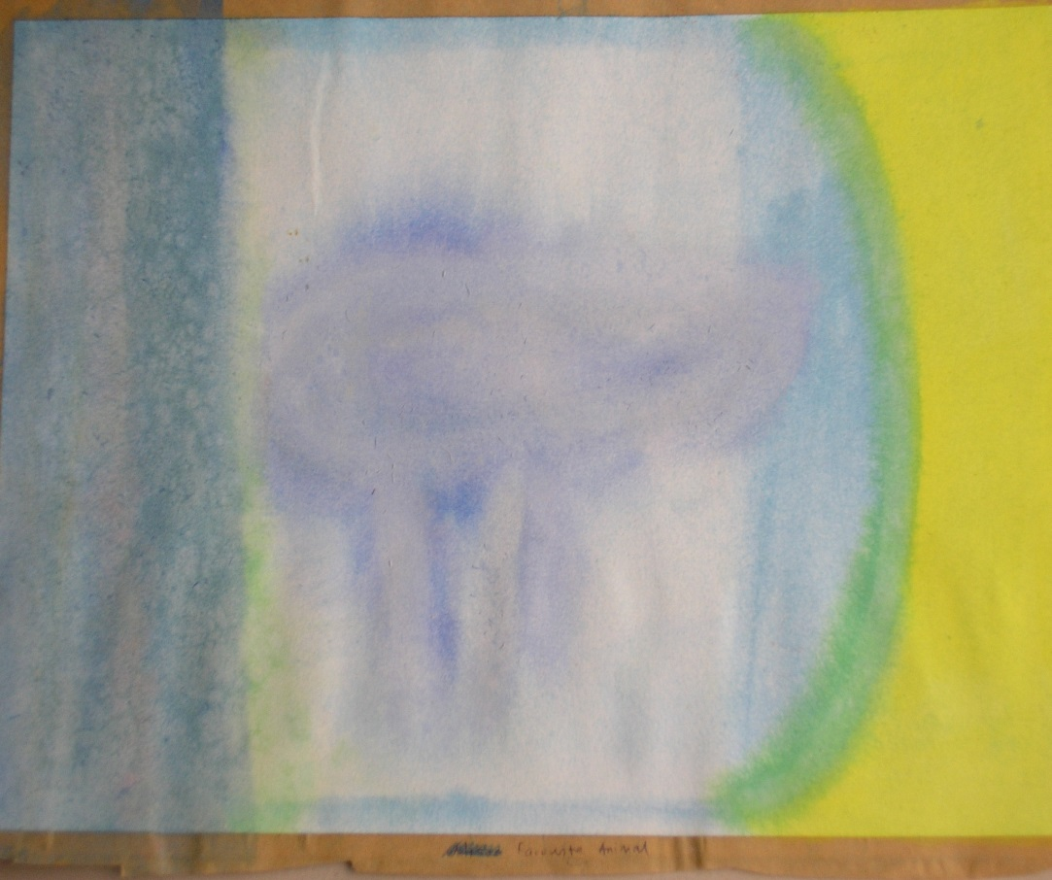
This is typical of her first pictures. She constantly builds up and then dissolves her pictures, This one is of her favourite animal (a sheep). Other observations about her: hasty stutters, changes her mind, warts on right eyelid, distorted fingernails, cannot say ‘I’, only her name. She likes ‘hot food and ice cream’ (a typical contradictory comment) She dislikes fish, eggs and cheese. (although next time she may disagree with herself). Unable to recognise colours, or at least changes her mind about what they are when shown(blue, no red, no green, no blue) Incidentally Mind changeable, in children, Puls is in capitals underlined. She loves to be part of a group and hates to be alone. When asked how old she is says she is 3 years old.
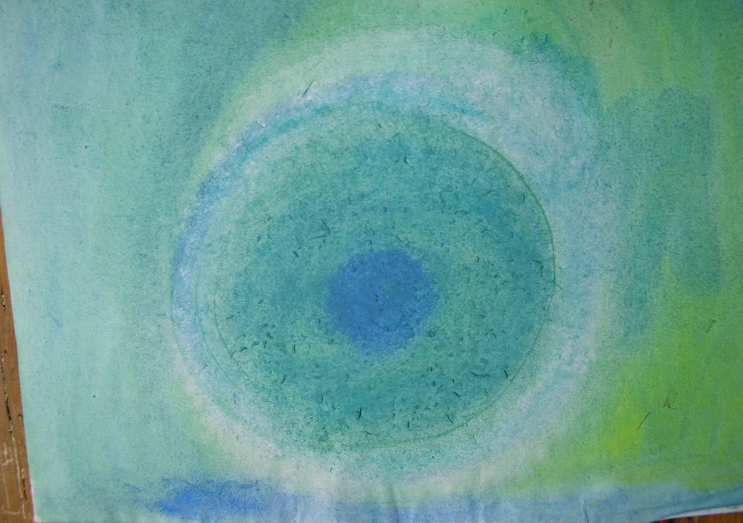
Another building up and dissolving picture of a circle. In order to create a form I asked her to draw around a plate, but she attempts to dissolve the edges
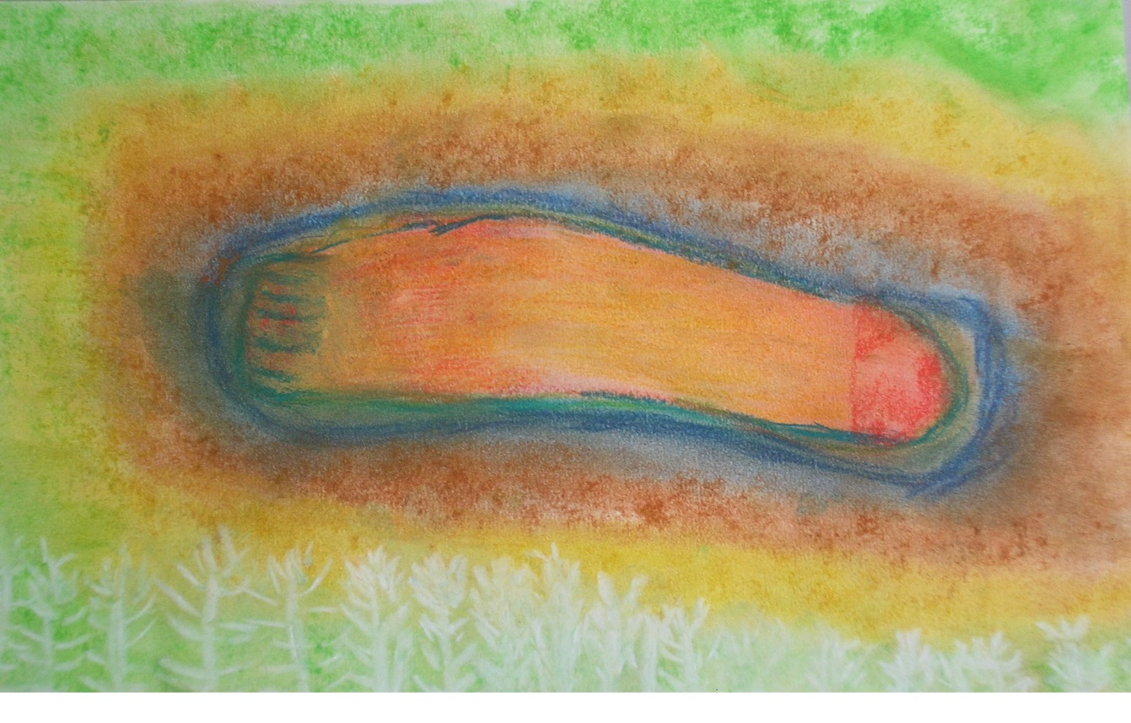
In order to help her establish her identity she was asked to paint a picture of herself. She painted this in May 05. I saw that it was her foot and that there seemed to be some inflammation on the heel. She never complained about her ailments; she always said ‘A is alright, A is happy’ However when I asked to see her foot I saw that it was massively built up with excess skin and severely cracked on the heel.
Two months later I was allowed to treat her and we started with graphites and thuja. She later chose Anantherum from Ulrich Welte’s colour chart; a remedy which has warty growths, stammering and fissured tongue (which she had) in the symptom picture. After a course of remedies focusing on her heel including Lyc, Ant-crud, Puls, Silica, and Causticum she was painting like this; a picture of an angel
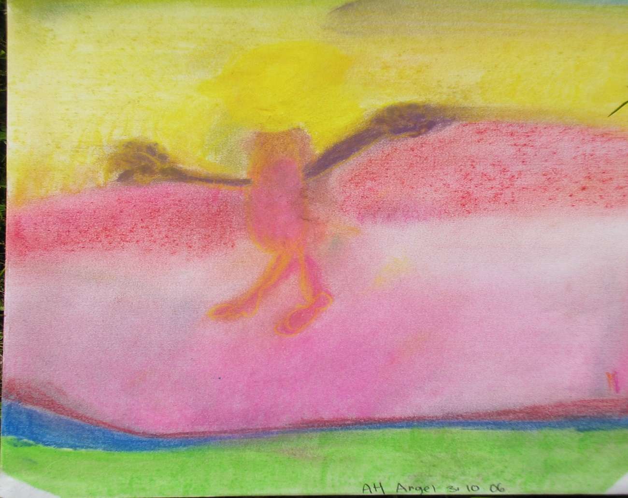
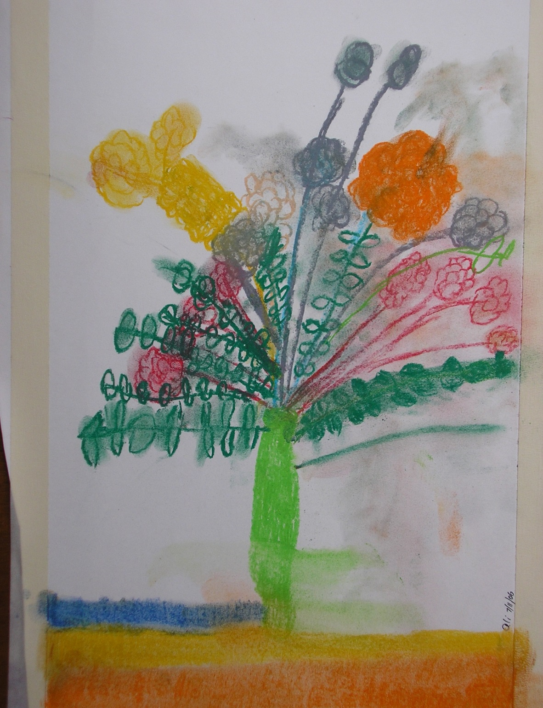
Then came this picture of a bunch of flowers. Well observed and differentiated. Able to name red as a colour.
By now she was saying ‘I’ instead of her name. She was more decisive; didn’t keep changing her mind. Stammering was less. As her feet improved she stopped building up and dissolving her pictures

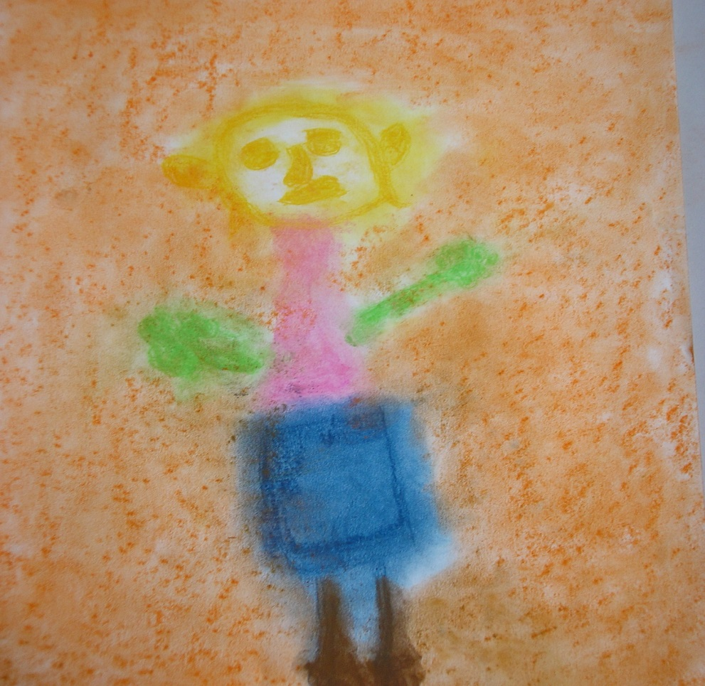
The picture above is of her friend. In order to know herself, she is now able to learn to recognise herself in others
This is another friend
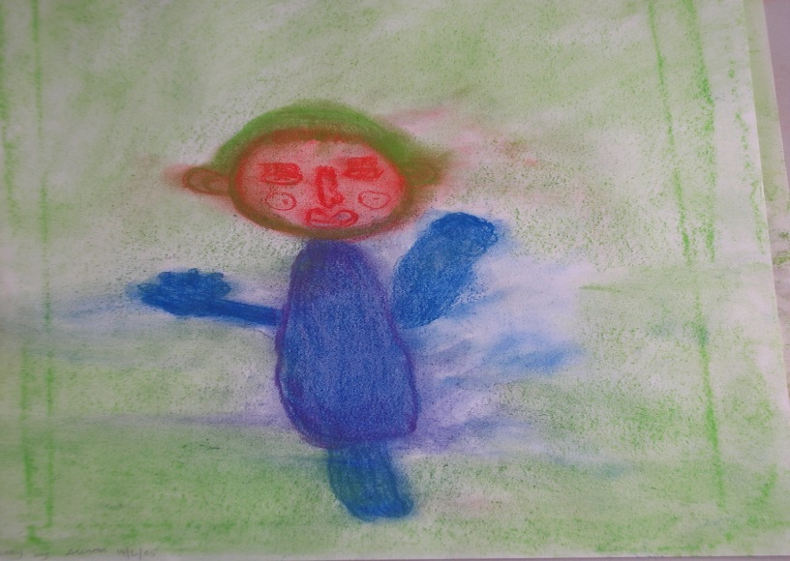
Pulsatilla was given 4 times, once with a dose of leprominium (skin conditions and premature greying,).I think we had the most success with Puls and her pictures continue to represent plant like growths.. Each time she appeared to be able to produce more detailed pictures. She still likes sheep. Why? Because they are happy!

